Regional Equestrian League-2019
PROSPECTUS

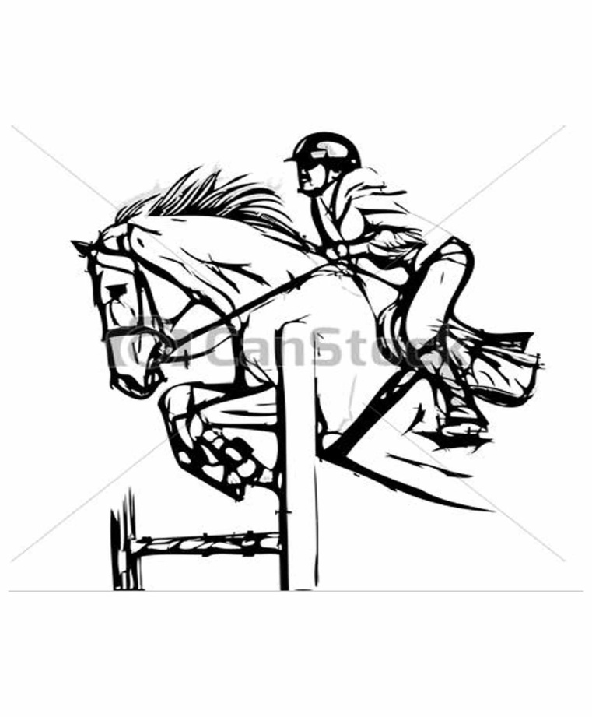

01-02 Nov.2019

AT
Sultanpur Lodhi
Organized by
PUNJAB EQUESTRIAN ASSOCIATION

REGIONAL EQUESTRIAN LEAGUE

INTRODUCTION

The Punjab Equestrian Association hosting the Regional Equestrian League on 01 & 02 Nov. 2019 according of the rules of the Equestrian Federation of India, at Sultanpur Lodhi, Distt Kapurthala. All or any information related to the prospectus, schedule of events or other details of the Championship can be received by communicating via e-mail: pbequestrianassociation@gmail.com or contacting the following officials of the Punjab Equestrian Association.

The details of the officers to be contacted for assistance or information are given below:-

Name & Designation | Phone No./Fax No. | E-mail
Organizing Secretary
Sh Rajpal Singh Sandhu,
Commandant, RTC, PAP,
Jalandhar Cantt.
Camp Commander  ShTalwinder Singh, DSP | 98148-15787
Show Secretary  Sub InspYoungbir Singh | 97799-09002 | pbequestrianassociation@gmail.com  youngbirsingh@gmail.com

1. Venue. Regional Equestrian League will be conducted on 01 & 02 Nov. 2019 at Sultanpur Lodhi, Distt Kapurthala

2. List of Events & Schedule of Events are attached as Annexure I and II.

3. Entries. All Entries will be made on the entry form attached as Appendix III and will be as per the E.F.I. technical guidelines.

4. In case of any objection, original birth certificate / matriculation certificate will have to be produced before Appeal Committee.

5. No entry will be accepted without an entry- fee. This rule will be implemented across the board for all events.
6. Entry fees:-Rs. 500-00 per rider/event.
Payment: All entries must be made to the Show Secretary at the show office.
7. No entry will be accepted after the Draw of Lots for the particular event.

8. A horse cannot be transferred from one event to another without paying an additional entry fee for the event, a horse once entered, in any event cannot be substituted by another horse for any reason whatsoever.

9. In the Tent Pegging Event the minimum age requirement of a rider is 16 yrs.

10. Closing date for receipt of entries.The last date for submission of entries is 30 Oct 2019 (5PM).

11. The payment for the entries can be submitted once the teams arrive. Otherwise, all entries on prescribed forms must reach the show office by 30 Oct. 2019. The entries can be sent by Post/email at the following addresses:-

Postal Address | Commandant, RTC,  PAP, Jalandhar Cantt
Email Address | pbequestrianassociation@gmail.com

Note:- After the closing date all entries will be accepted as POST ENTRIES, which will be double of the normal entry for the particular event.

12. Registration of horses :-All Horses participating in Regional Equestrian League must be registered with EFI.EFI No.’s will be displayed on the bridle, when the horse moves out of the stables camping area during stay during REL.
13. EFI Rider ID:- All riders participating in the Regional Equestrian League must have the Rider Identification No’s allotted by the Equestrian Federation of India. No rider will be allowed to participate in Regional Equestrian League. Riders participating only in Punjab State Senior Equestrian Championship and Sultanpur Lodhi Horse Show are not required to register with EFI.

14. Withdrawal, Substitution or Change of Entry/Rider.

(a) Withdrawal. The Entry fee of a horse entered for any event will not be refunded if the horse does not participate in the event.

(b) Change of Riders.

- Riders or Horse can be changed only on medical ground with sufficient Medical Certificate.
- Once an event has started being judged, no change in rider will be accepted.
15. Camp.
(i) The camp will be located at Sultanpur Lodhi. The Camp In- charge will earmark the site for each contingent. The Camp will become operational on 29 Oct 2019 and will be closed on 03 Nov 2019.
(ii) Horses, riders, grooms/farriers coming to participate in Regional Equestrian League will stay in the camping area. No team will be allowed to enter the camping area before 29 Oct. 2019.

(iii) Advance information about the number of participants/ horses must be conveyed to the organizers by 25 Oct 2019 so as to finalize camping arrangements.

16. Self-Containment. All teams coming to participate in the Regional Equestrian League must be self-contained, i.e they should bring their own equipment, tent, feed, fodder, cooks, farriers and transport etc.

17. Climate. The climate in the month of November is very cold. Participants are advised to make requisite arrangements.

18. Lighting. The participants are requested to bring their own Hurricane Lanterns/ Petromax Lamps for emergency use. Power / light will be provided under camp arrangements where feasible.

19. Discipline. All the participants saying in the camp will be under the camp in-charge for the purpose of discipline.

20. Fire Precautions. All the participants are required to undertake fire-fighting precaution in their respective areas.

21. Sanitation and Hygiene. All participants should observe proper sanitation and hygienic measures. There should be proper disposal of litter at pre designated location.

22. Medical Assistance. Medical assistance will be provided at the camp site and competition area.

23. Veterinary Assistance. Veterinary assistance will be available at the Camp site and competition area.

24. Responsibility. The organizing committee accepts no responsibility for any injury or loss to entrant/competitor through accident or any other cause. Neither the organizers nor the vet / medico will be held responsible for the consequences of the first aid or other medical treatment given to any injured horse or rider.

25. Whips and Spurs. As per EFI and relevant FEI rules per discipline. Any form of beating, punishment and brutality to horse will lead to disqualification & elimination of the competitor.

26. Coggin’s & Mallein Test. All participating horses must possess a negative Coggins&Mallein Test Report. No horse will be allowed inside the camping area without valid Coggins & Mallein test reports.

27. Cancellation. The Organizing committee may cancel any event for any reason entirely at their discretion. In such case, the entry fee will be refunded.

28. Reporting for each class. All horses will report to the Arena Steward half an hour before the time of judging of the class. Any entrant not reporting in time will be eliminated unless the exhibitor shows good cause for the delay. The Arena Steward has full authority to take disciplinary action.

29. Spectators/outside assistance. The spectators or the supporters of the participants are not to interfere with the Judges. The Arena Steward has the right to eliminate any participant who has outside help. Once the event has commenced, all spectators and helpers are to clear the arena. The Judges’ decision will be final. Parents must not enter the arena or dispute the decision or confront the Judges.

30. Veterinary Inspection. All participants for the Regional Equestrian League are required to present their horses for veterinary Inspection (Trotting Parade) on 30 Oct. 2019 at 03.00 PM.in the competition grounds along with a copy of the Coggins&Mallein Test report and EFI passports of the horses.

31. Conduct Rules.

(a) The events of REL will be conducted & adjudged as per rules of EFI (Equestrian Federation of India).
(b) The events are judged by the panel of judges who are experts in the field of equestrian sports.
(c) The decision of the jury will be final.
32. Objections.

(a) Objections may only be lodged by owner or person responsible for horses taking part in the event.
(b) The objections must be lodged within half an hour of the result announced.
(c) The appeal committee’s verdict will be final and binding on all participants.
(d) A deposit of Rs 2000/- must accompany all objections in regard to any matter during the competitions.
33. DRESS CODE and Saddlery:-
i) Dress of riders and Saddlery of Horse: Dress code for participating riders and Saddlery of participating horses will be as per as per FEI/EFI guidelines for the particular events. Team incharges/coaches will ensure that saddlery of their horses is as per guidelines, cleaned and fitted properly.

34. Miscellaneous.
(a) Should any questions arise not provided for, it must be referred to the organizing committee, whose decisions will be final.

(b) Scheduling time and entries are subject to alteration at the discretion of the organizing committee.

LIST OF EVENTS Annexure I

REGIONAL EQUESTRIAN LEAGUE

Sr. No | Events | Remarks
 | Novice Show Jumping Normal
 | Gd III Show Jumping Normal
 | Show Jumping Junior Normal
 | Show Jumping Children I
 | Show Jumping Children II
 | Tent Pegging

Annexure II

REGIONAL EQUESTRIAN LEAGUE
SCHEDULE OF EVENTS

01 Nov 2019

Sr. No | Events | Time | Venue
 | RELShow Jumping Children I | 02 PM | Show Jumping Arena
 | REL Show Jumping Children II | 03 PM | Show Jumping Arena
 | REL Tent Pegging (Round A) | 10-00 AM | Tent Pegging Track
 | Lunch | 01-02 PM
 | REL Show Jumping Junior Normal | 02-00 PM | Show Jumping Arena
 | REL Tent Pegging (Round B) | 03-00 PM | Tent Pegging Track

02 Nov 2019

 | REL Show Jumping Novice Normal | 08-00 AM | Show Jumping Arena
 | REL Show Jumping GD-III Normal | 10 AM | Show Jumping Arena

Annexure-III

Entry Form

Sr. No. | Name of Event | Name of Rider | Rider ID No. | Exhibitor |  |  |  |  | Entry Fee
 |  |  |  | Name of Horse | Color | Sex | Age | EFI No.

Signature

